Solutions Of One-Way ANOVA
- The hypothesis stating
N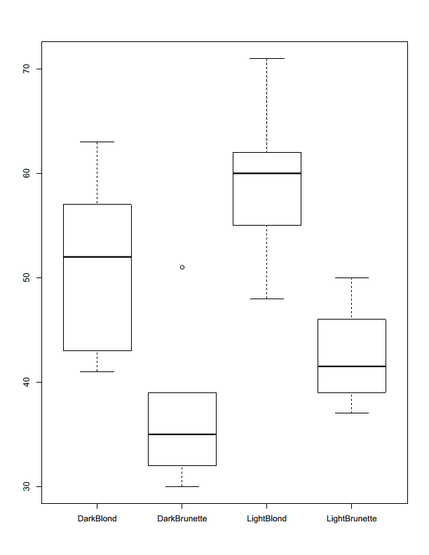ull Hypothesis – H₀: The mean pain are equal across some or (all) haircolour.
Alternative Hypothesis – H_{A}: The mean pain are not equal across some or (all) haircolour.
- Check the relevant conditions.
The samples means are independent.
By the show of a boxplot the sample means have a constant variance.

- Perform the overall F-test

Summary (ANOVA)
Df Sum Sq Mean Sq F-value Pr(>F)
Hair Colour 3 1361 453.6 6.791 0.00411 **
Residuals 15 1002 66.8
---
Signif.codes: 0 ‘***’ 0.001 ‘**’ 0.01 ‘*’ 0.05 ‘.’ 0.1 ‘ ’ 1

No significance level was provided, therefore we shall assume 𝛼 = 0.05.
Decision: Since p-value 0.00411 is less than 𝛼 = 0.05 we reject the null hypothesis.
Conclusion: At the 5% significance level, there is statistically significant evidence the mean pain varies across some (or all) hair colours.

- Conduct pairwise test to determine which groups are different from each other.
TukeyHSD(ANOVA)
Tukey multiple comparisons of means
95% family-wise confidence level

Fit: aov(formula = Pain ~ HairColour)

$HairColour
diff lwr upr p adj
DarkBrunette-DarkBlond -13.8 -28.696741 1.0967407 0.0740679
LightBlond-DarkBlond 8.0 -6.896741 22.8967407 0.4355768
LightBrunette-DarkBlond -8.7 -24.500380 7.1003795 0.4147283
LightBlond-DarkBrunette 21.8 6.903259 36.6967407 0.0037079
LightBrunette-DarkBrunette 5.1 -10.700380 20.9003795 0.7893211
LightBrunette-LightBlond -16.7 -32.500380 -0.8996205 0.0366467

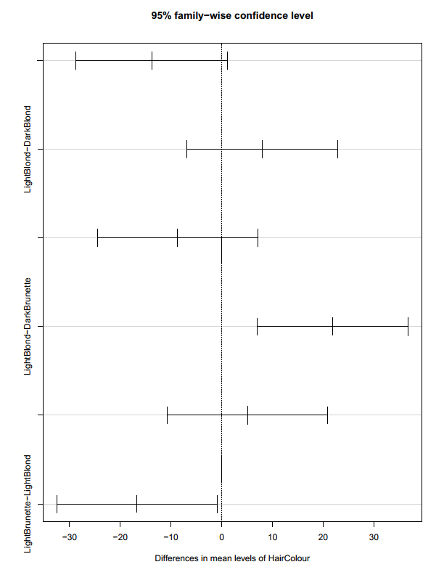

From the post analysis only two comparisons (the bolded values) lies below our significant level (0.05).

